todo to on a new pc

1.create new "Logins" on the SQL Server:

SSMS -> in Object Explorer -> Security-> Logins -> add "IIS APPPOOL\VolunteersProjectAppPool".

To this add dbreader and dbwriter

2. select on_needed_DB -> right-click on_needed_DB -> Permissions -> View server permission ->

-> in Logins and roles select login created on point 1 -> in bellow section (permission for ...) checked in Grant column what we need.

Screenshot for point 1

Soon …

Screenshot for point 2

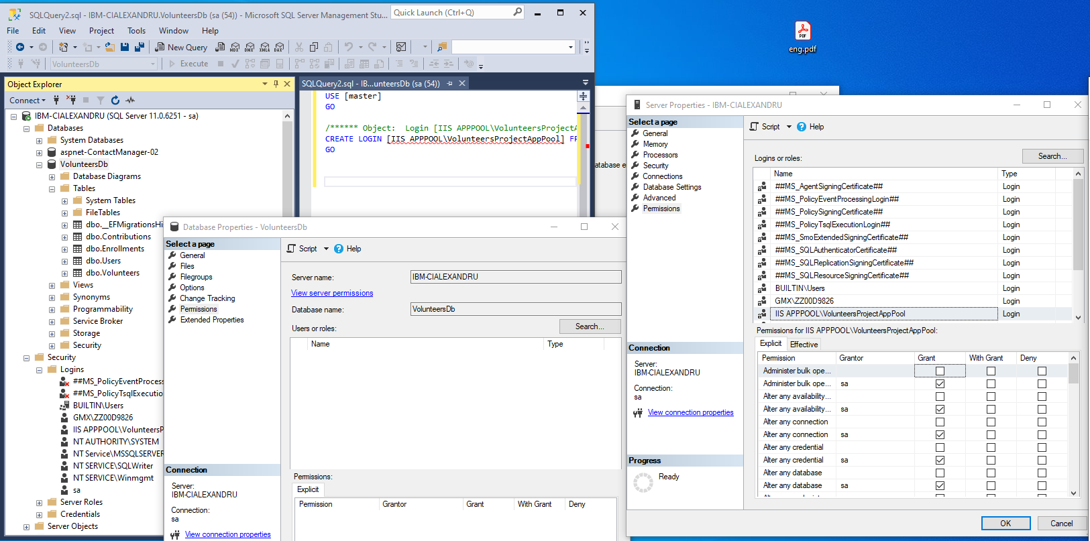

Link: https://stackoverflow.com/questions/7698286/login-failed-for-user-iis-apppool-asp-net-v4-0